Android Email Configuration
This guide explains how to configure your Android device to access your email account.This tutorial was created running the Android 6 OS. If you are using different hardware or a different OS version, these instructions may differ.

How do I find my email cluster?

In order to setup your email client, you will need to know which email cluster your account is hosted on. If you don't know this information, you can check with your email service provider, or try logging into webmail at:

Cluster A:
http://mail.hostedemail.com

Cluster B:
http://mail.b.hostedemail.com

If you are able to successfully login to the webmail interface, then you have found your mail cluster. If you are not able to login to either cluster, please contact your email service provider for support.

Step 1: Open the Email application
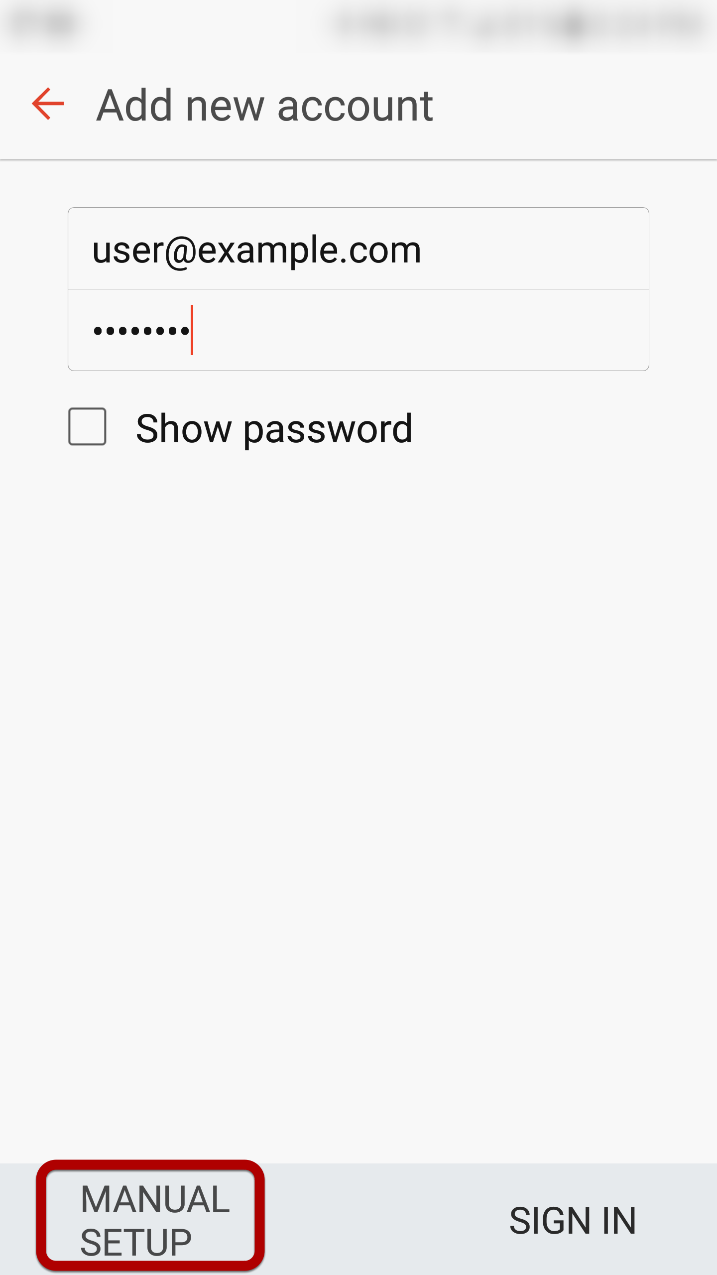
Enter your email address and select Manual Setup

Step 2: Select account type
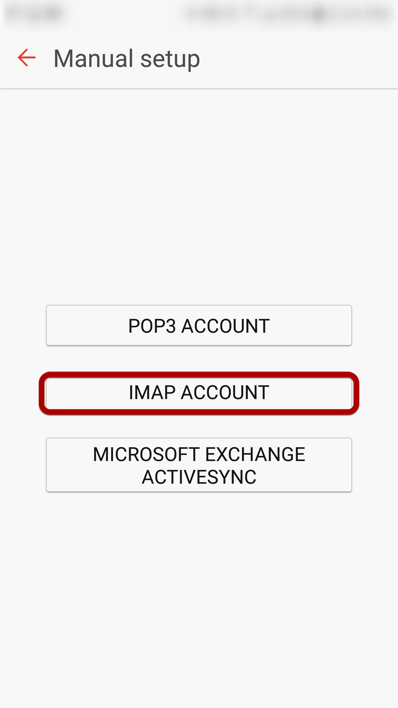
Select IMAP Account

Step 3: Enter Incoming Account Settings
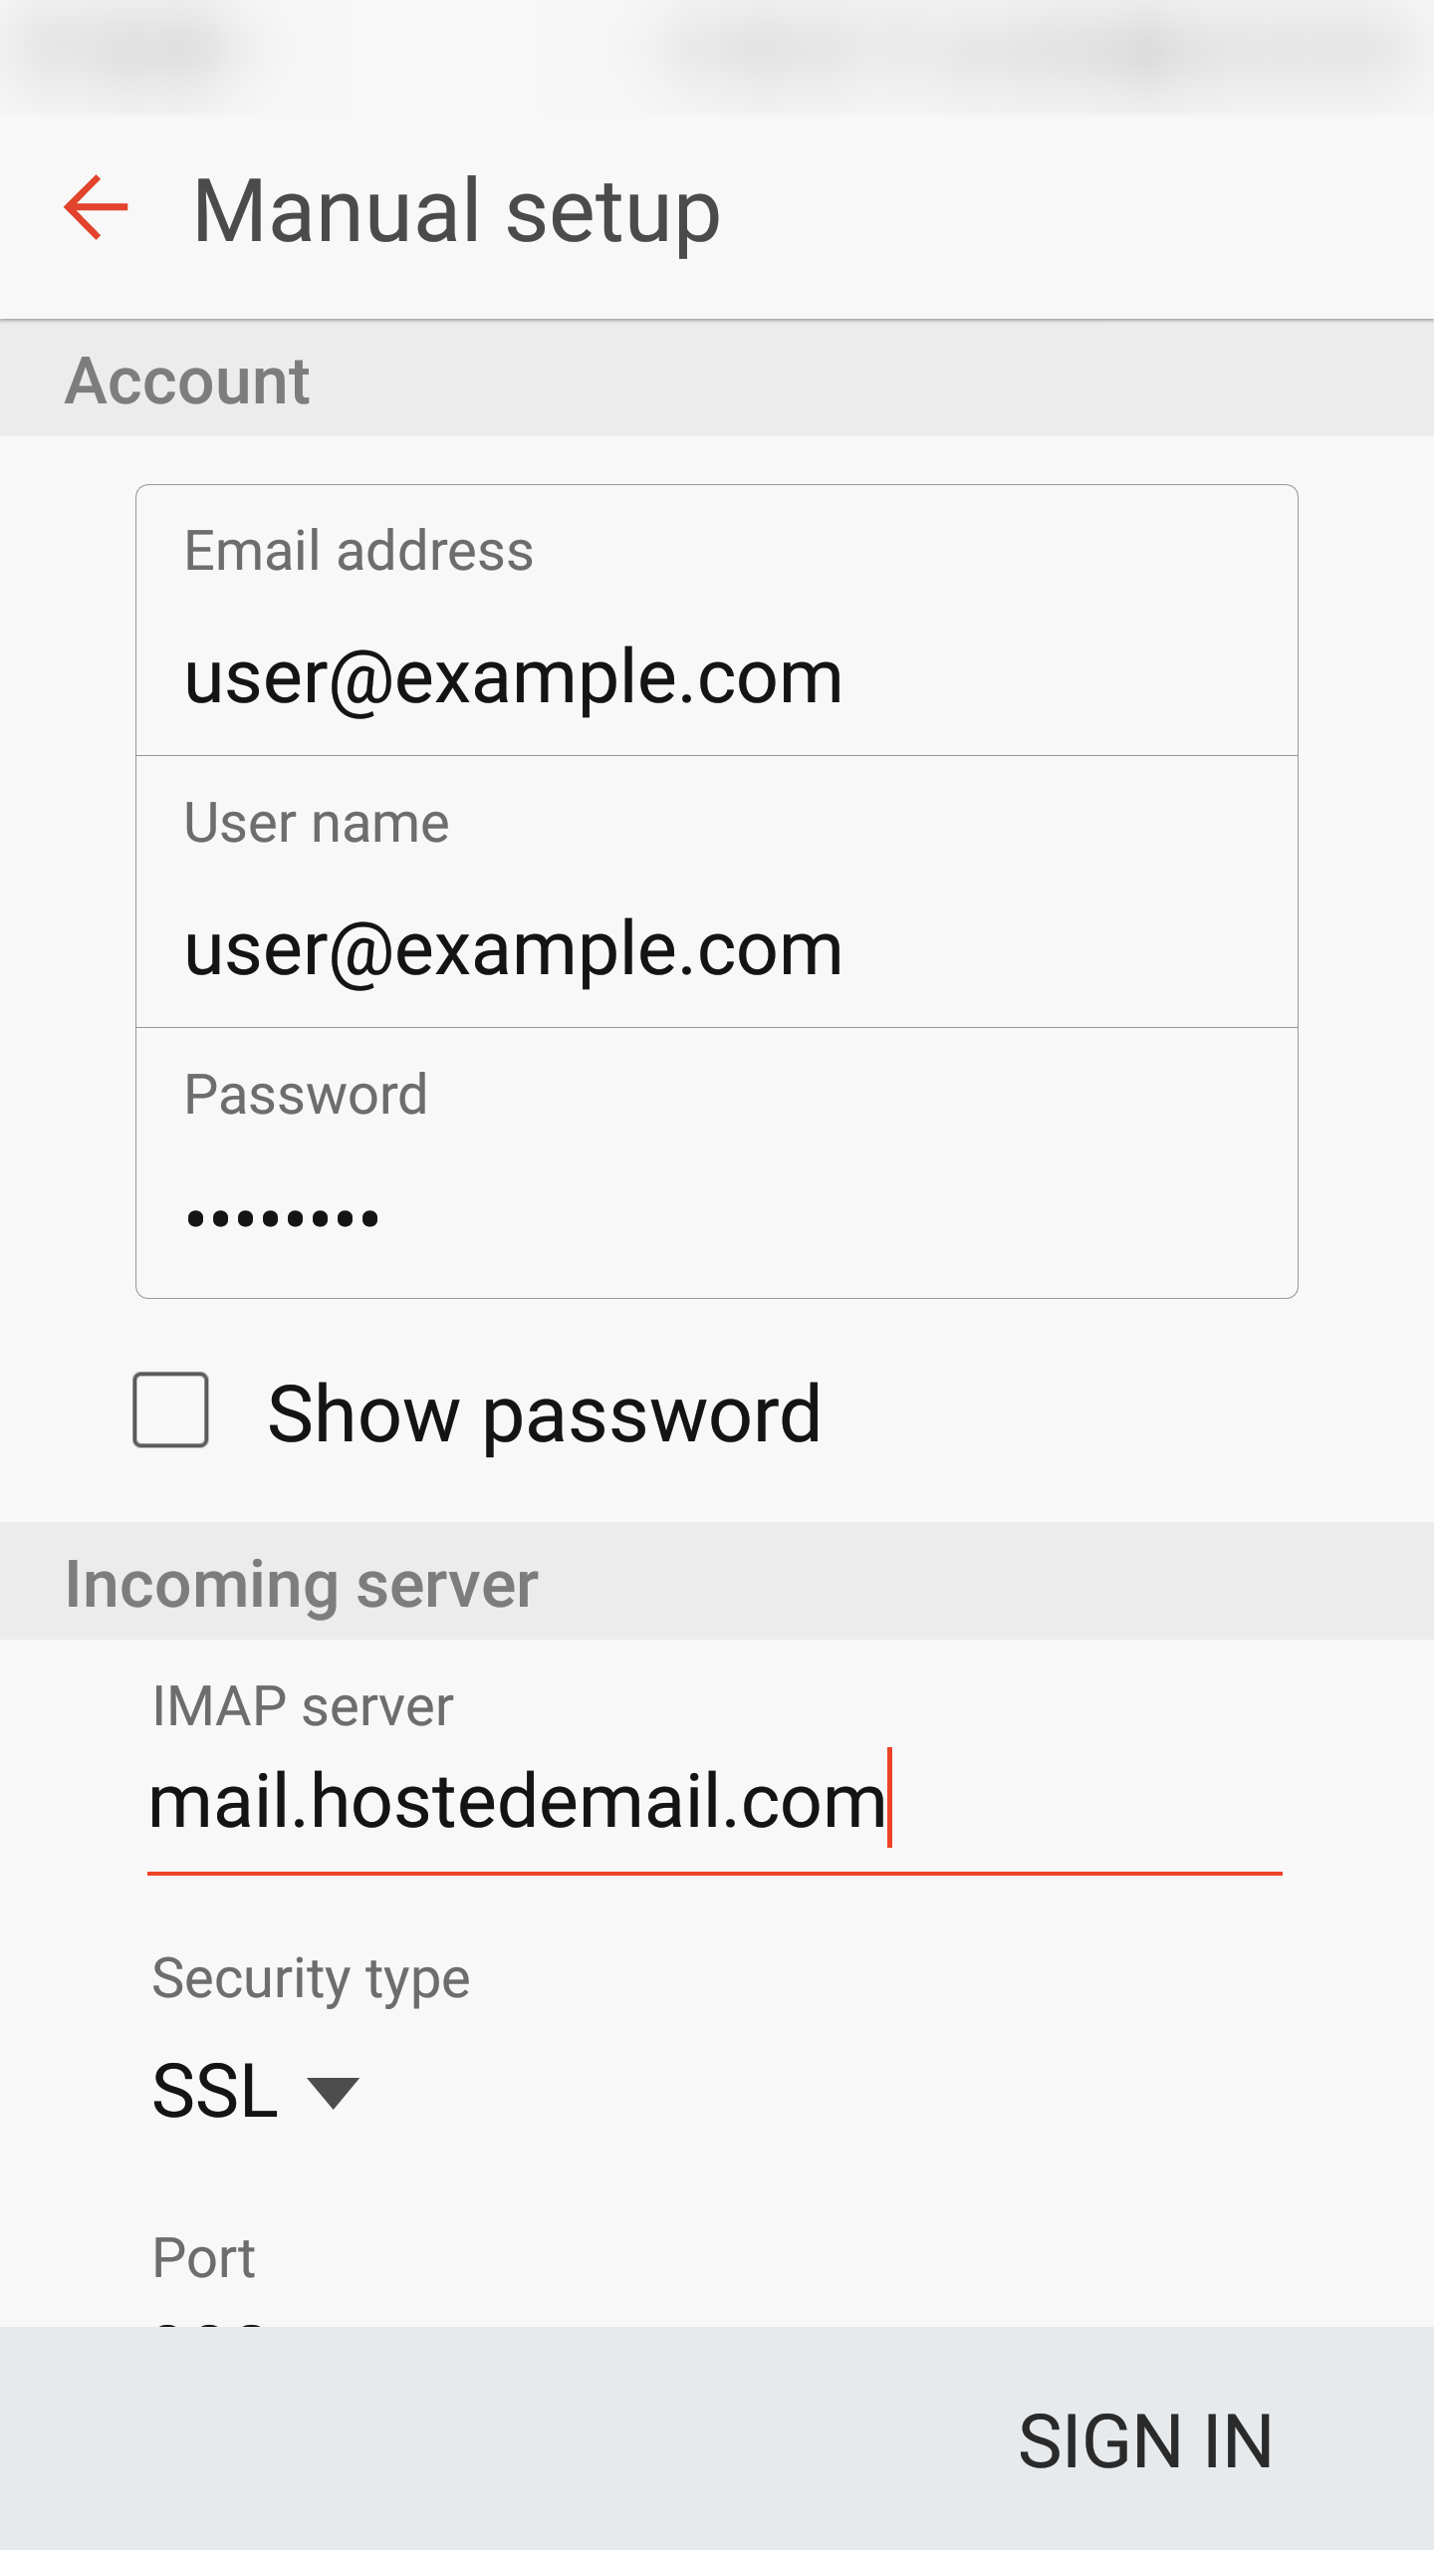
Enter the following information:
Username Enter your full email address.
Password
The Password field is automatically filled in with the password that you created when you set up your email account.
IMAP server
This is the name of the server which holds your email. Enter mail.hostedemail.com (Cluster A) or mail.b.hostedemail.com (Cluster B)
Port:
993

Step 4: Enter Outgoing Server Settings
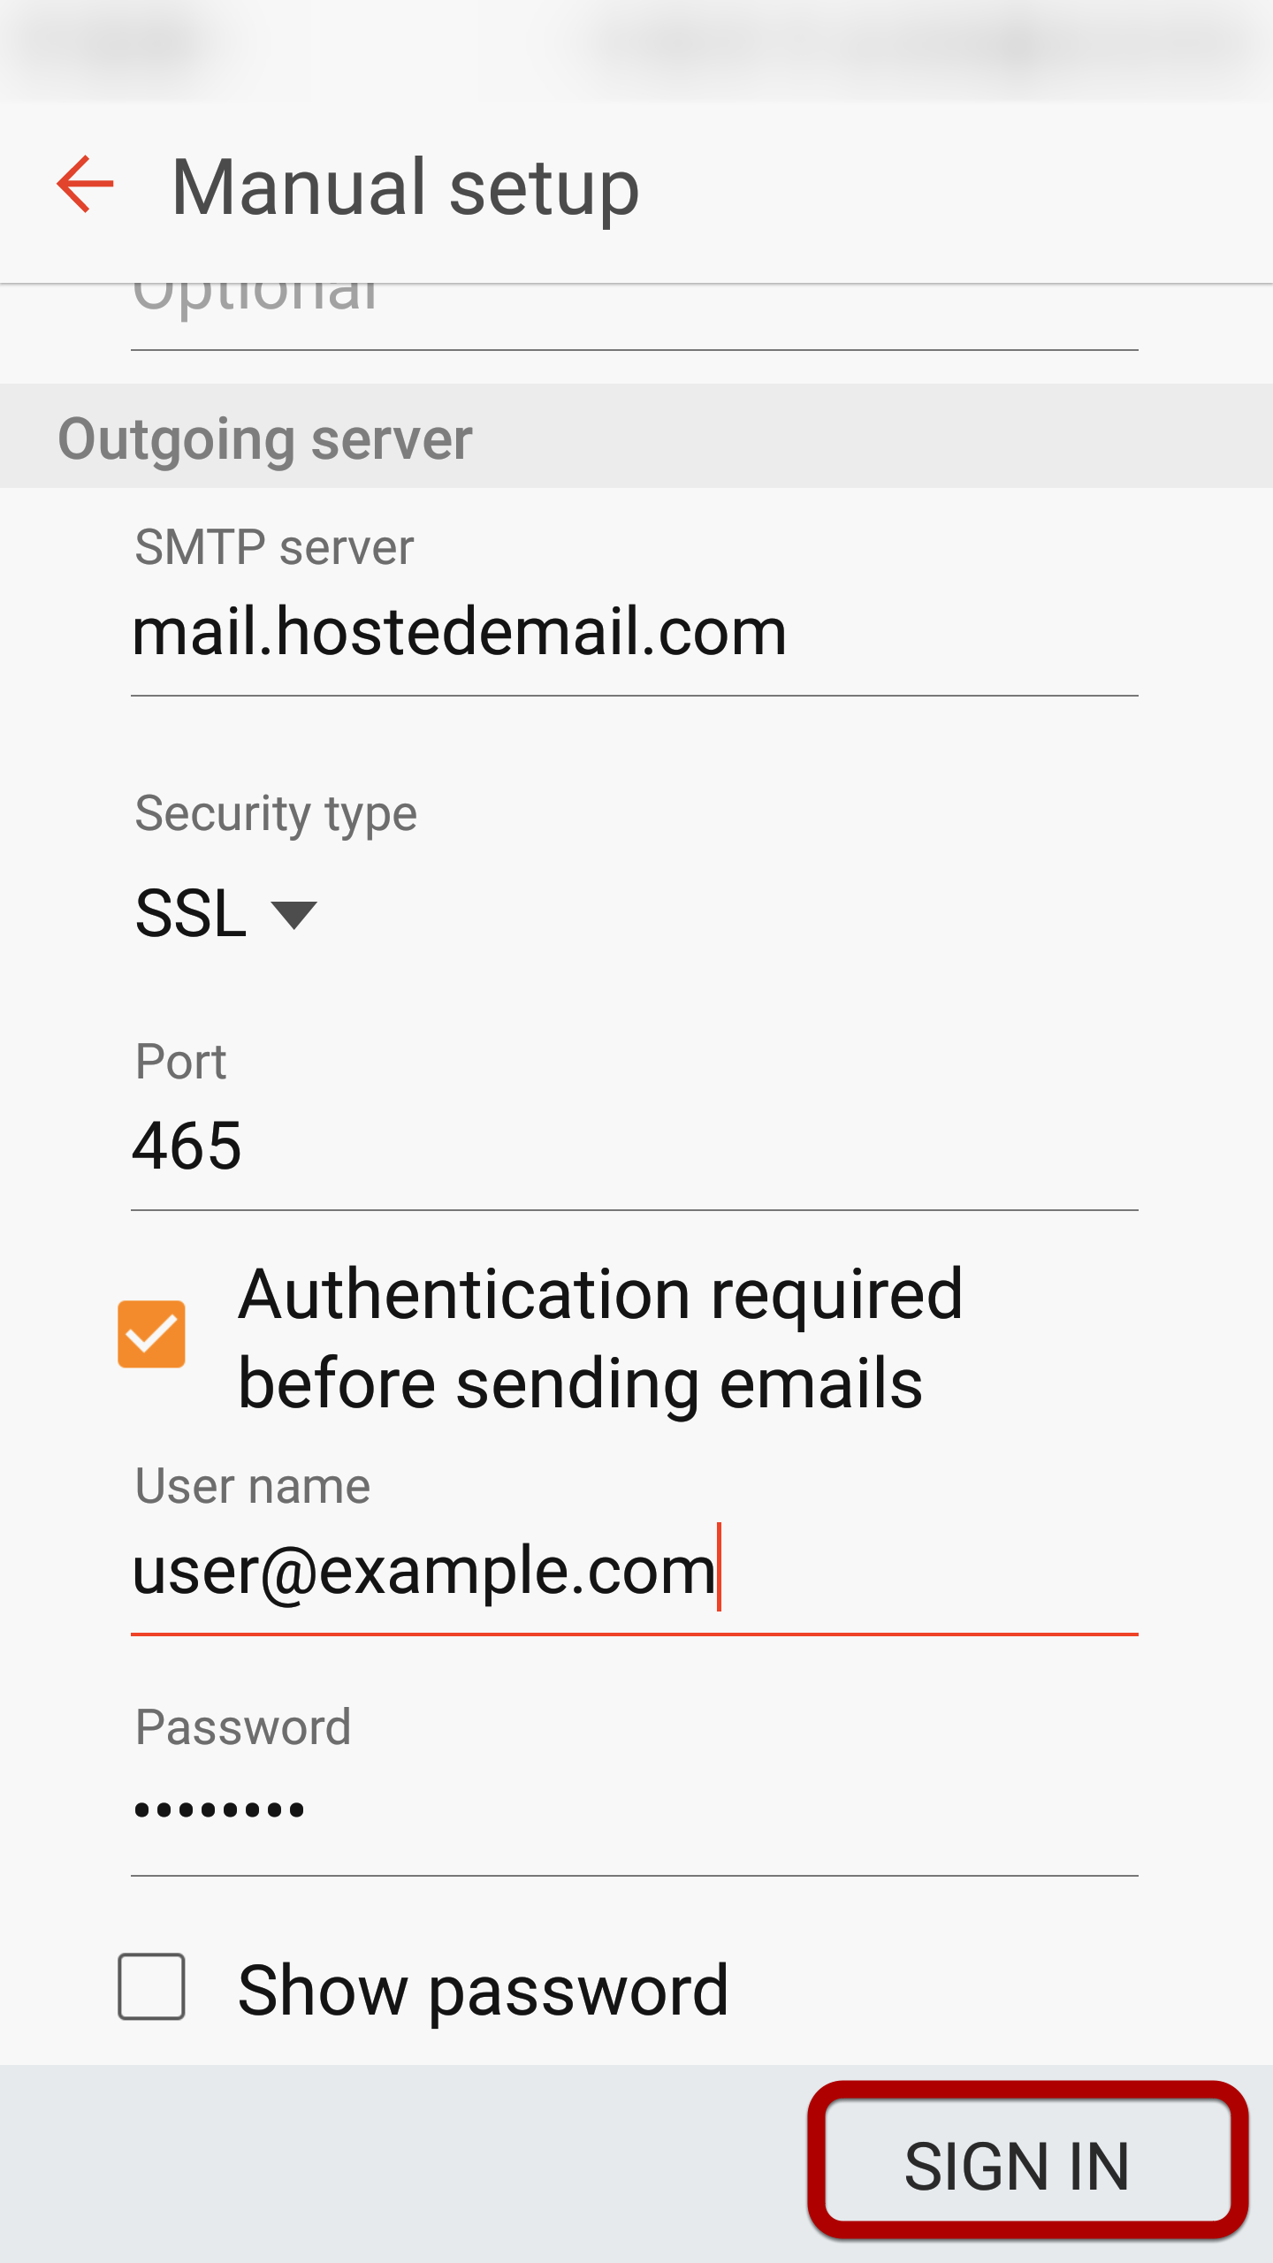
Enter the following information:
SMTP Server:
mail.hostedemail.com (Cluster A) or mail.b.hostedemail.com (Cluster B)
Port: 465
Security Type: SSL / TLS
Username: Your email address
Password:
Your email account password
Click Sign In to complete the setup process.

