Mac Mail Email Setup
In this tutorial we will be guiding you through the process of configuring email on Mac Mail. We are using Mac Mail Version 10.2 on OS X . If you are using a different version or operating system, these instructions may differ.

How do I find my email cluster?

In order to setup your email client, you will need to know which email cluster your account is hosted on. If you don't know this information, you can check with your email service provider, or try logging into webmail at:

Cluster A:
http://mail.hostedemail.com

Cluster B:
http://mail.b.hostedemail.com

If you are able to successfully login to the webmail interface, then you have found your mail cluster. If you are not able to login to either cluster, please contact your email service provider for support.

Step 1: Add Account
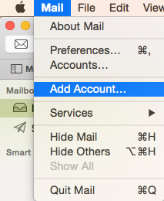
Launch Mac Mail, click on Mail and then select Add Account.

Step 2: Select Account Type
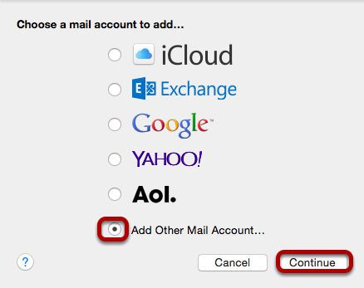
Choose Add Other Mail Account and click Continue.

Step 3: Enter Account Information
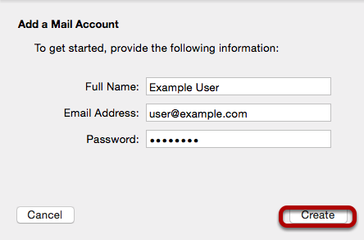
Enter the following information:
Full Name:
This is the name that will appear on all outgoing mail from this account.
Email Address:
The full email address of your account.
Password:
The password of your email account.
Then click Create.

Step 4: Manually Configure Account
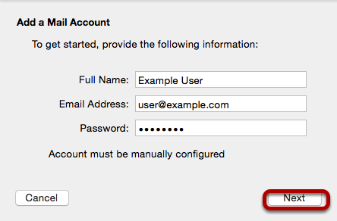
The system will prompt you that manual account configuration is required. Click Next.

Step 5: Enter Incoming Mail Server Information
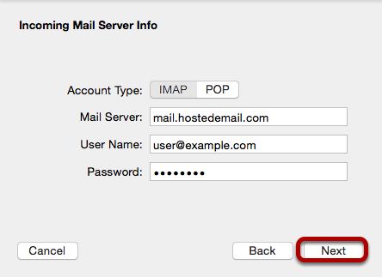
Enter the following information:
Account Type:
We recommend IMAP.
Mail Server:
mail.hostedemail.com (Cluster A) or mailb.hostedemail.com (Cluster B)
User Name:
Your full email address.
Password:
Your email account password.

Step 6: Enter Incoming Server Port Information
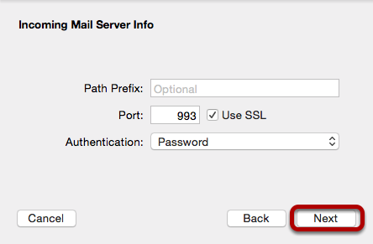
Enter the following information
Port:
993 (IMAP or 995 (POP)
Click Next.

Step 7: Enter Outgoing Mail Server Information
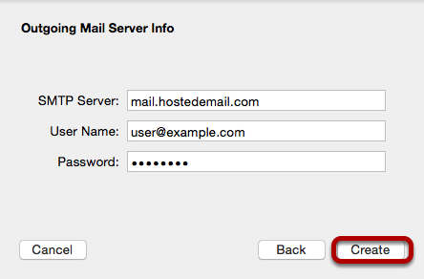
Enter the following information:
SMTP Server:
mail.hostedemail.com (Cluster A) or mailb.hostedemail.com (Cluster B)
User Name:
Your full email address.
Password:
Your email account password.

Step 8: Enter Outgoing Mail Server Port
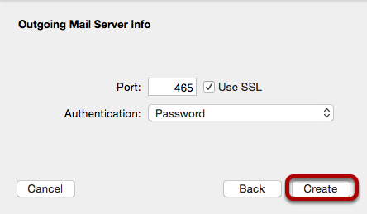
Enter the following information
Port:
465
Click Create.

