iOS 10 Email Configuration
This guide explains how to configure your iPhone to access your email account.

This tutorial was created using an iPhone running iOS 10. If you are using different hardware or a different OS version, these instructions may differ.

How do I find my email cluster?

In order to setup your email client, you will need to know which email cluster your account is hosted on. If you don't know this information, you can check with your email service provider, or try logging into webmail at:

Cluster A:
http://mail.hostedemail.com

Cluster B:
http://mail.b.hostedemail.com

If you are able to successfully login to the webmail interface, then you have found your mail cluster. If you are not able to login to either cluster, please contact your email service provider for support.

Step 1: Click on Settings on the home screen.
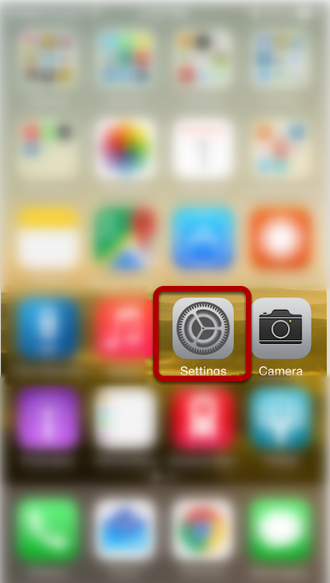

Step 2: Click on Mail
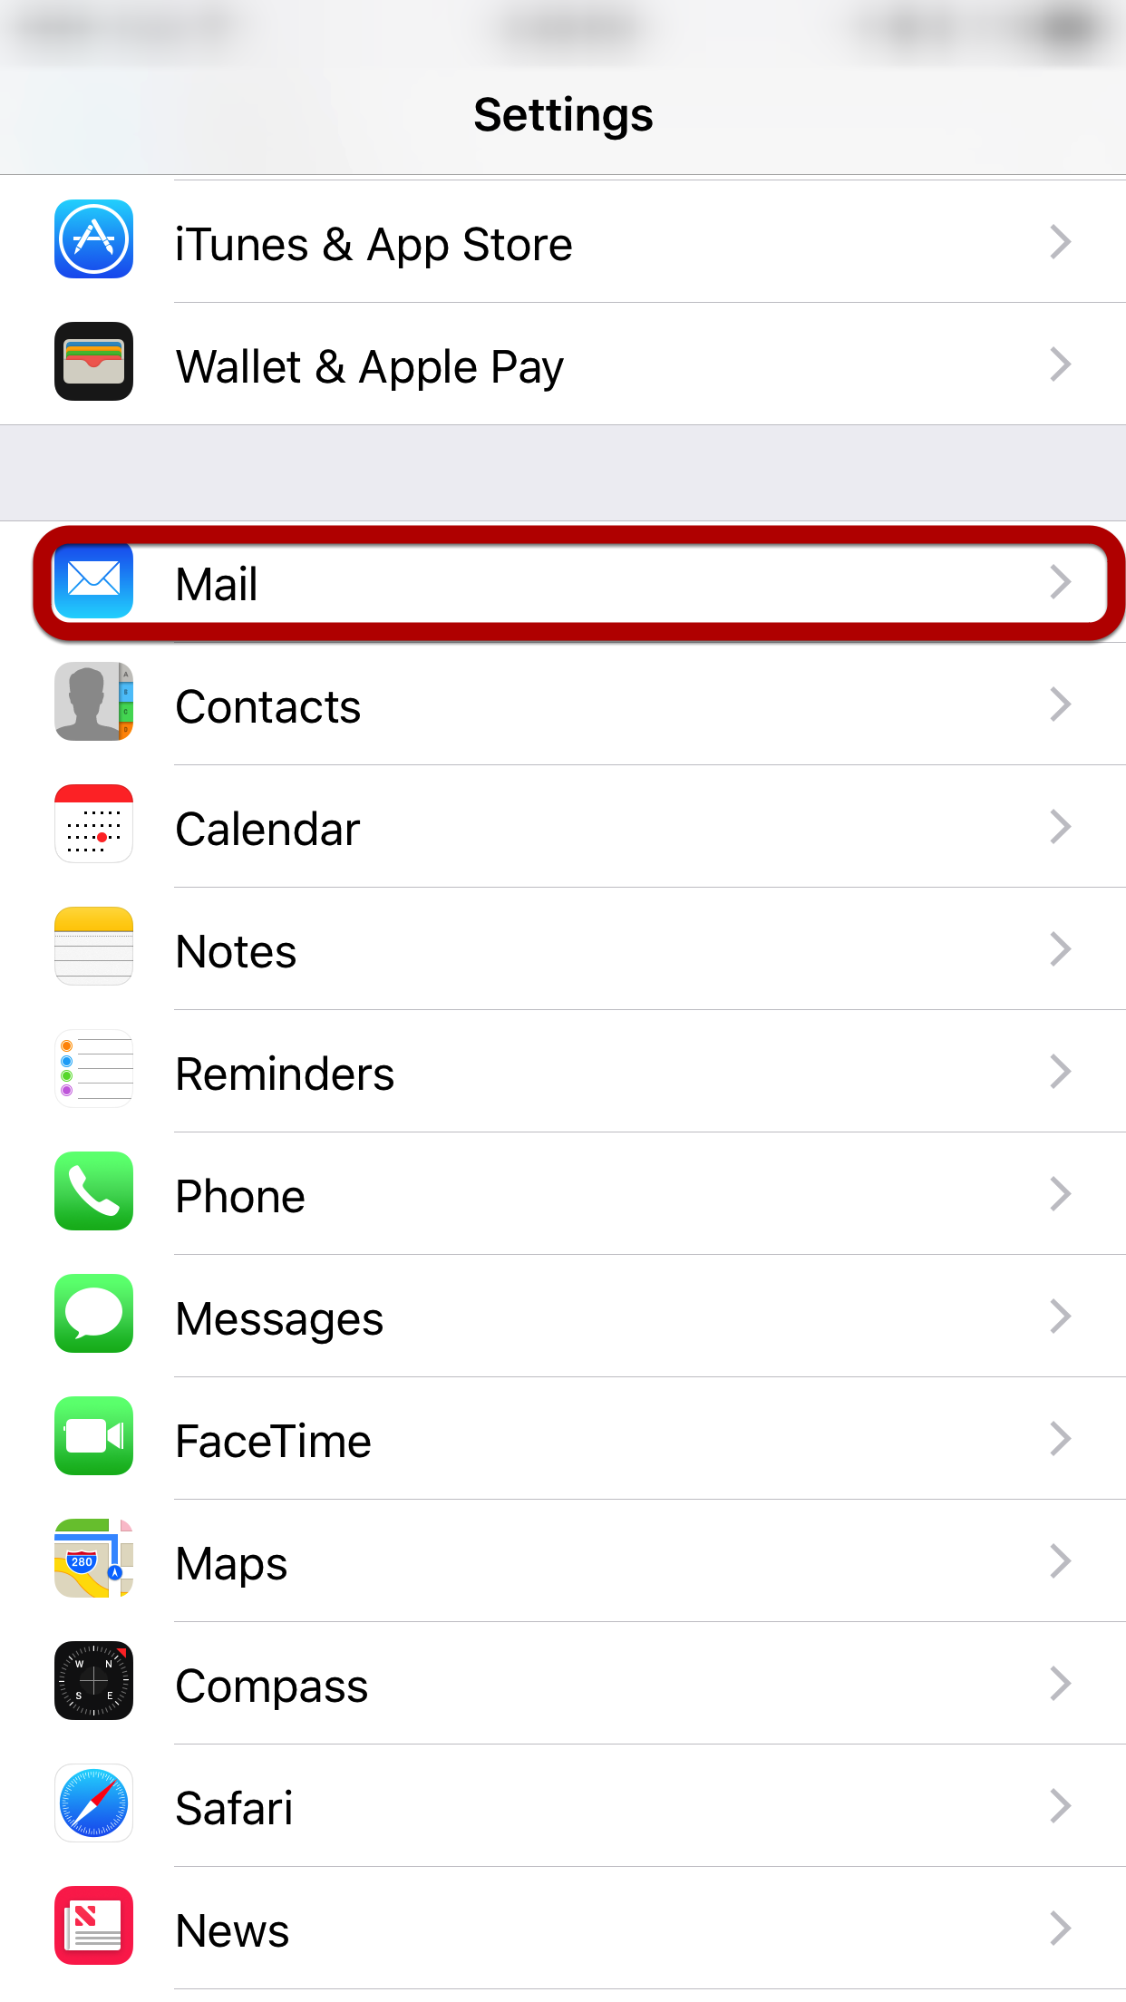

Step 3: Click on Accounts
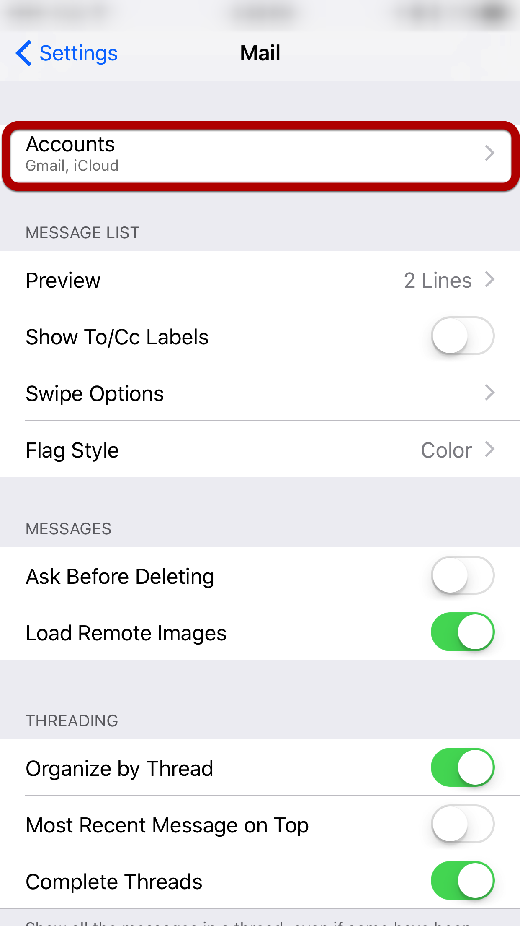

Step 4: Click on Add Account
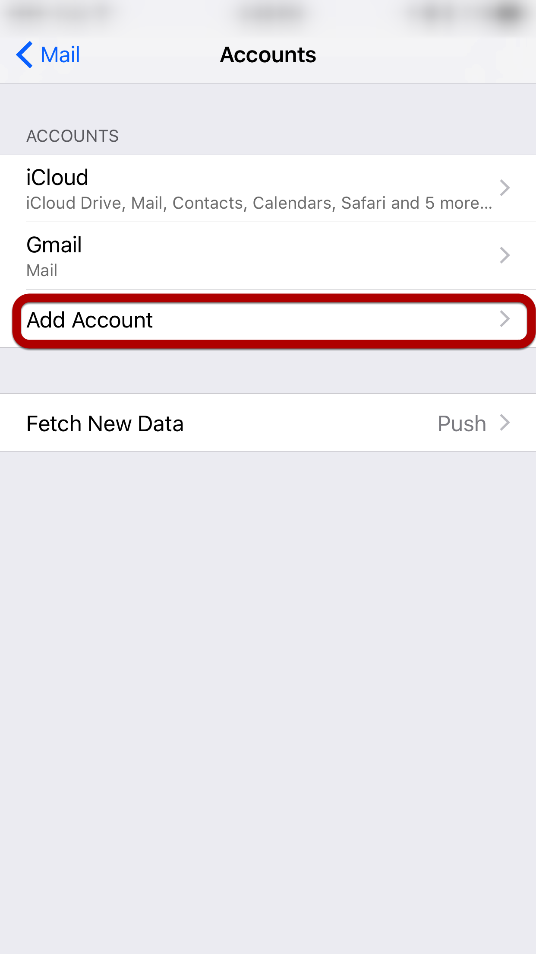

Step 5: Select "Other"
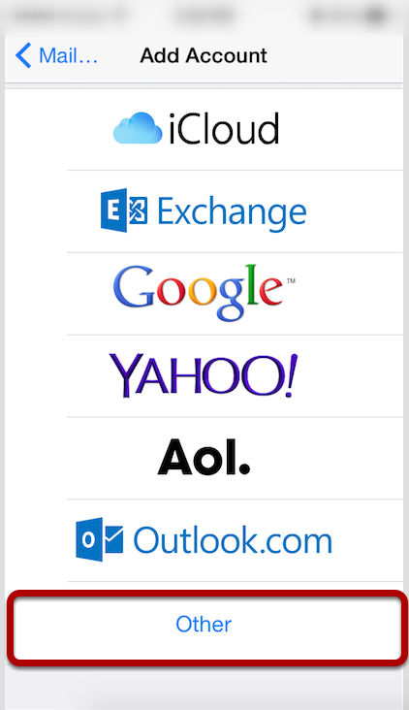

Step 6: Click "Add Mail Account"
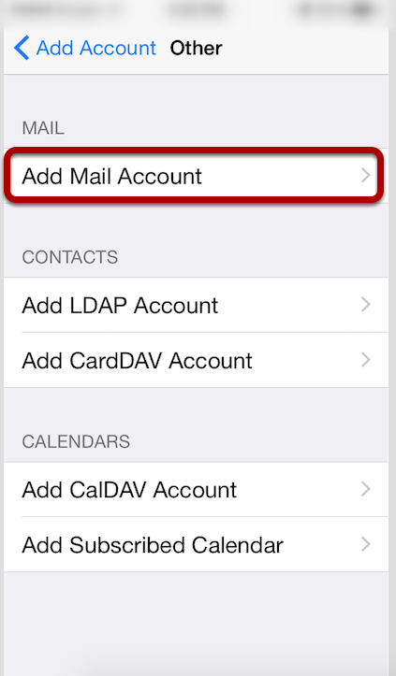

Step 7: Enter Account Information
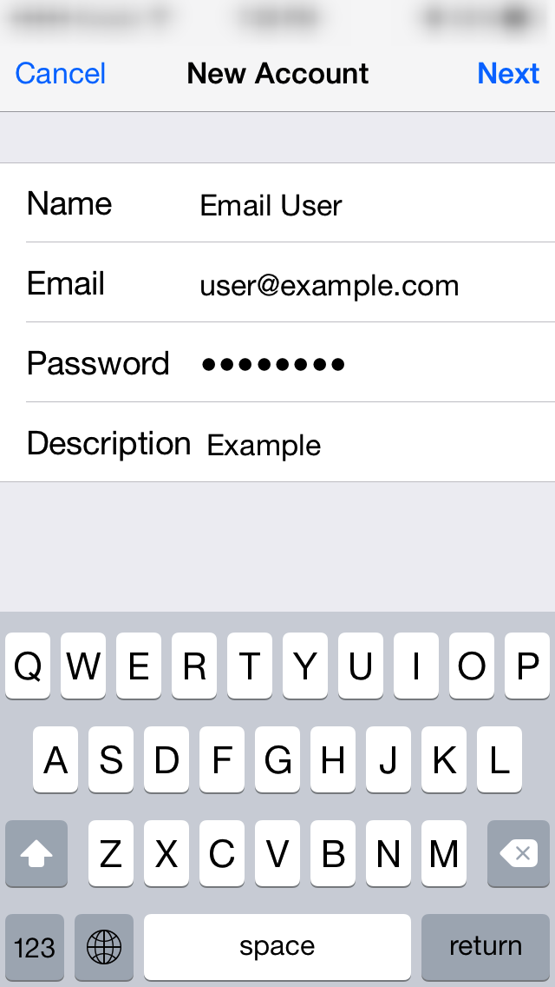
Enter the following settings:
Name
The name displayed when you send email
Address
Your full email address
Password
Your email account password
Description
Account description of your choice
Tap Next.

Step 8: Select Account Type
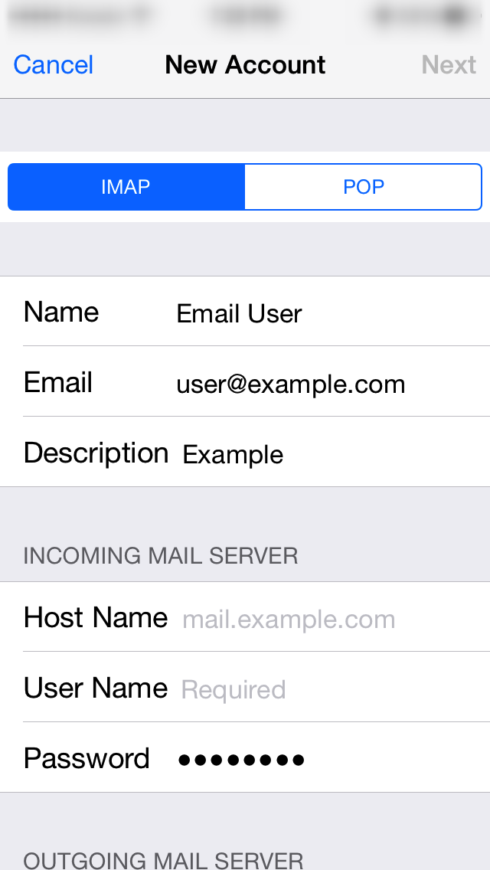
Select your account type on this page. We recommend IMAP for mobile devices as messages are stored on the server which provides better syncing with multiple devices.

Step 9: Enter Incoming Mail Server Information
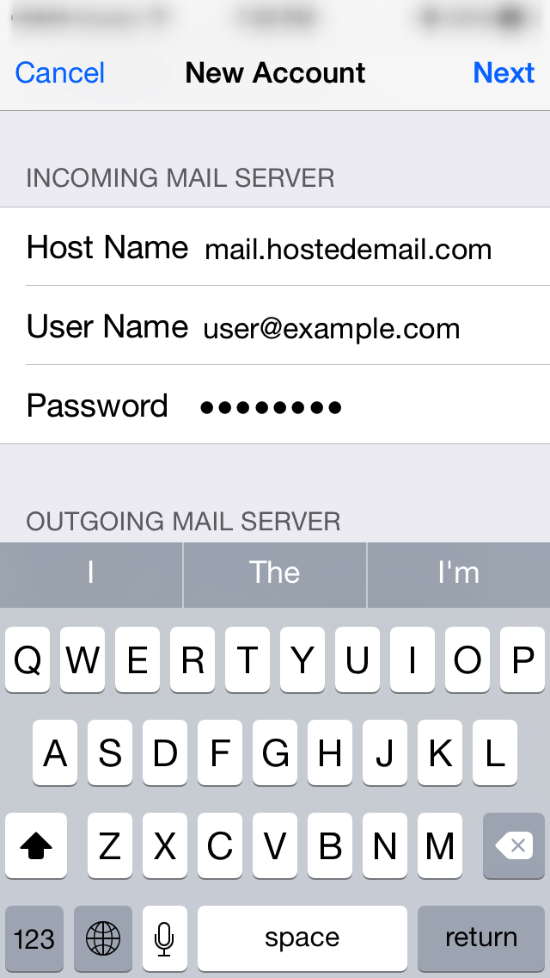
Under the Incoming Mail Server section, enter the following settings.

Host Name:
mail.hostedemail.com (Cluster A) or mail.b.hostedemail.com (Cluster B)
User Name:
Your email account
Password:
Your email account password
Scroll down to the Outgoing Mail Server section.

Step 10: Enter Outgoing Mail Server Information
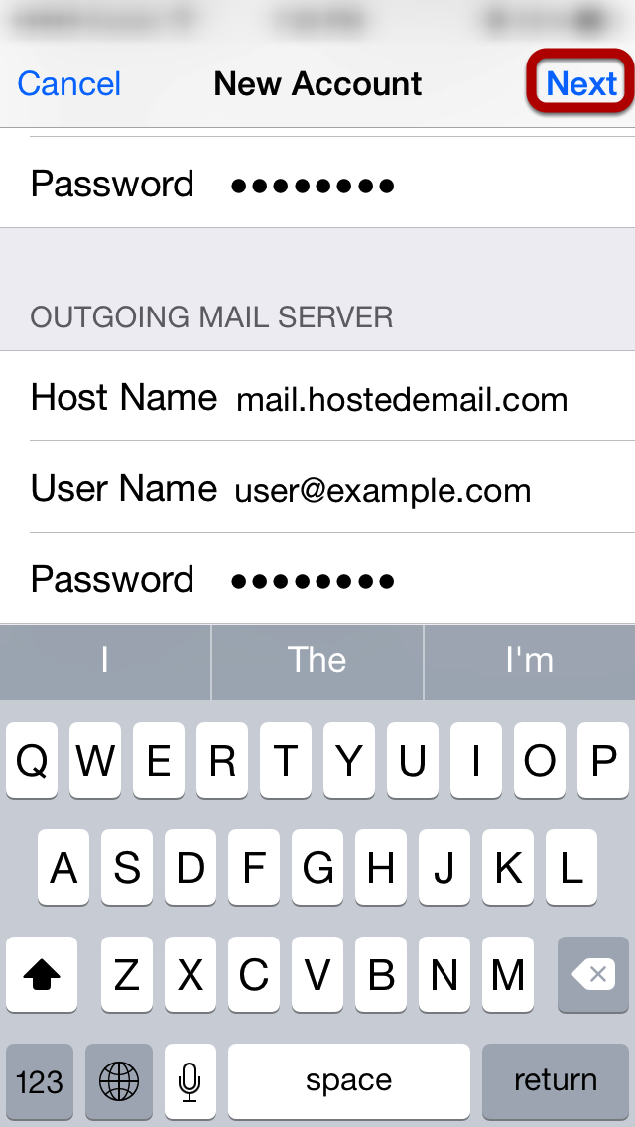
Under the Outgoing Mail Server section, enter the following settings:
Host Name:
mail.hostedemail.com (Cluster A) or mail.b.hostedemail.com (Cluster B)
User Name:
Your email account
Password:
Your email account password
Please note that the outgoing mail server setting is not optional. You will need to enter this information in order to properly configure the account.
Tap Next to complete account setup.

